To enter email:

Email: [cschrissie@icloud.com](mailto:cschrissie@icloud.com) Or

Mail: [alexgiles36@gmail.com](mailto:alexgiles36@gmail.com) with name club EA registration number date of birth and and personal best for events by Friday 1st September.

**North East Throwing Festival**

**Wednesday 6th September 2017**

**Location: Monkton Stadium, Jarrow**

**Starts at 6:30pm**

*Pay on collection of numbers.* ***£3 per a event***

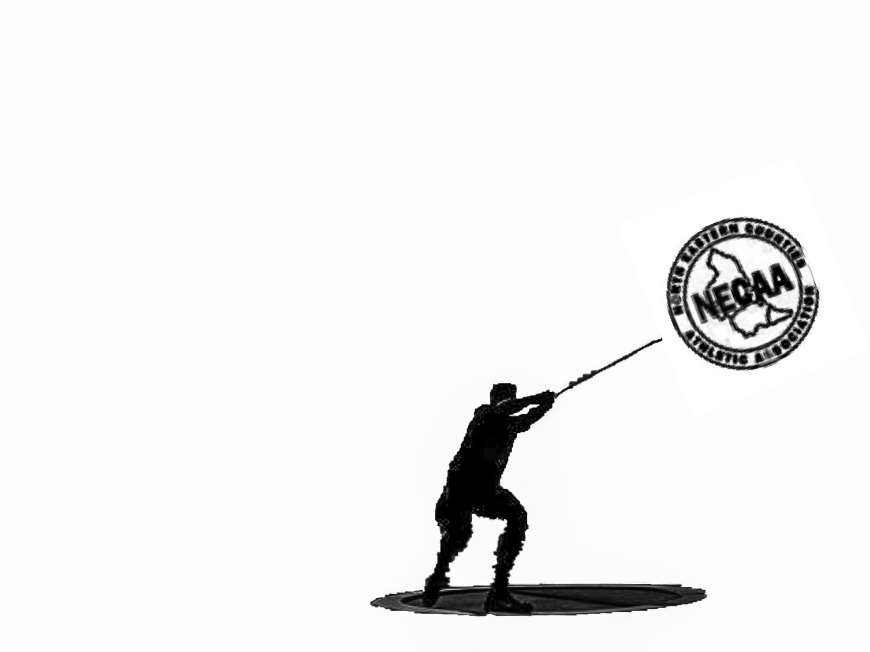

***Entry standards***

|  |  |
| --- | --- |
| Under 13 Girls  Shot: 6.5 m  Hammer: 15m | Under 13 Boys  Shot: 7m  Hammer: 15m |
| Under 15 Girls  Shot: 8.5m  Hammer:20m | Under 15 Boys  Shot: 10m  Hammer: 20m |
| Under 17 Women  Shot: 9m  Hammer: 30m | Under 17 Men  Shot: 11m  Hammer: 25m |
| Under 20 Women  Shot: 9.5m  Hammer: 30m | Under 20 Men  Shot: 11m  Hammer: 30m |
| Senior Women  Shot: 10.5m  Hammer: 30m | Senior Men  Shot: 12m  Hammer: 35m |

* Seeded entries for each age group.
* Event limit 60 competitors in total
* Supported and Officiated through NECAA

The entry list will be published on:

<HTTPS://www.facebook.com/NEThrowingFestivel>

On the 2nd September

NO LATE ENTRIES WILL BE ACCEPTED

Awards for top 3 male and female in each event

An award to the top club for the overall throws title