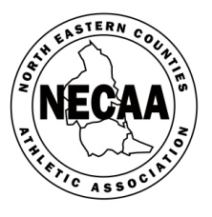 |  |  | NORTH EASTERN COUNTIES ATHLETIC ASSOCIATION  111th ANNUAL CROSS COUNTRY CHAMPIONSHIPS  (Under UKA & ECCA Rules,2016060)
HOSTED BY DERWENTSIDE AC/ELVET STRIDERS
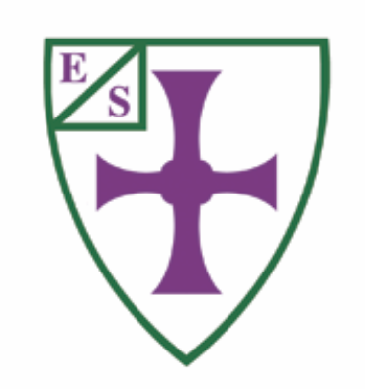
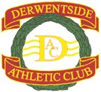

AYKLEY HEADS, Saturday
10th December 2016 at 11am
 | Under 13 Boys Championship | 3k |  | 11.00am | First three for team scorers | Ages: 11 and 12 years on 31st August 2016 (11 years on day of competition)
 | Under 13 Girls Championship | 3k |  | 11.15am | First three for team scorers | Ages: 11 and 12 years on 31st August 2016 (11 years on day of competition)
 | Under 15 Boys Championship | 4.5k |  | 11.30am | First three for team scorers | Ages: 13 and 14 years on 31st August 2016
 | Under 15 Girls Championship | 4.5k |  | 11.40am | First three for team scorers | Ages: 13 and 14 years on 31st August 2016
 | Under 17/20 Women Championship | 6k |  | 12.00noon | First three for combined Under 17/20 team scorers | Under 17 Women Ages: 15 and 16 years on 31st August 2016  Under 20 Women Ages: 17, 18 and 19 years on 31st August 2016
 | Under 20 Men Championship | 8k |  | 12.25pm | First three for team scorers | Ages: 17, 18 and 19 years on 31st August 2016
 | Senior Men Championship | 12k |  | 1.00pm | First six for team scorers | Age: Must exceed 20 years on 31st August 2016
 | Senior Women Championship | 8k |  | 1.55pm | First four for team scorers | Age: Must exceed 20 years on 31st August 2016
 | Under 17 Men Championship | 6k |  | 2.30pm | First three for team scorers | Ages: 15 and 16 years on 31st August 2016
 | Middlesbrough & Cleveland Harriers Centenary Trophy |  |  |  | Trophy for best overall club - Six points to first team place - down to one point for sixth in all races - Highest aggregate will be the winners.
 | JC Kennedy Trophy |  |  |  | Trophy for best women overall performance – Six points to first team place – down to one point for sixth in all races – Highest aggregate will be the winners.
 | Gallery Jewellers Trophy |  |  |  | Trophy for best men overall performance – Six points to first team place – down to one point for sixth in all races – Highest aggregate will be the winners.

PLEASE NOTE ENTRIES MUST BE SUBMITTED BY TEAM MANAGERS/CLUB SECRETARIES ONLY

Conditions of Entry: The championships are open to members of North Eastern Counties AA Clubs affiliated to England Athletics, 9-month residential qualification or individuals with North Eastern Counties birth qualification. All entries must be first claim membership. See UK Athletics Rule 9.
Note to club secretaries: Entries are as individuals and first runner’s home with team qualification as required in each race will score for team competition. All the required details must be completed carefully – entries without England Athletics registration numbers and date of births will not be accepted. Separate entry for each age group. Any problems with entries contact Paul Brown pbrown5@hotmail.co.uk

Entries: Entries to be completed online via Sportsoft Race Results – www.race-results.co.uk
Entry fees: Under 13, 15, 17, 20 of both genders £4 (no team fee). Senior Men/ Women £5 (no team fee).

Entry closing date: FRIDAY11th NOVEMBER 2016. No late entries. NB ONLINE ENTRIES ONLY.
Club colours: All competitors must wear registered club colours. Failure to do so may lead to disqualification. See UK Athletics Rule 17(2).

Registration: Numbers to be collected on the day from the registration at Durham County Hall Reception, DH15UQ.
Presentation: Individual presentations will take place immediately after each race on the course and team presentations as per timetable in the final instructions. The last two team presentations will be announced on the day asap. 2015 trophies must be returned to the presentation area on the December 10th.

Championship headquarters: Durham County Council, County Hall, Durham, DH15UQ. General enquiries: NECAA XC Sec. Archie Jenkins archiemeadowriggs@btinternet.com.

Parking/Travel Full details will be sent to club secretaries.

UNDER 11 NON-CHAMPIONSHIP RUN: ENTRIES (£1) WILL BE TAKEN ON THE DAY NO LATER THAN 10.00AM AT COUNTY HALL RECEPTION. BOYS 10.35AM START, GIRLS 10.40AM. BOTH 1.5K.

Northern Athletics Cross Country Championships: Saturday January 28th, Knowsley.

English National Cross Country Championships: Saturday February 25th, Nottingham.
Inter-Counties Cross Country Championships: Saturday March11th, Prestwold Hall, Loughborough. The first three finishers in championships will have automatic selection for NECAA teams. All other cross country races will be taken into account for further selection, in particular the Northern Championships will indicate current form, with teams being selected the following day.

